 

**Placement Empowerment Program**

***Cloud Computing and DevOps Centre***

Create a Simple Backup Script: Create a script that backs up your entire Git repository to a local folder daily

Name: Vijaya Nandana M Department: CSE



**Introduction**

Backing up your Git repositories is a crucial part of version control management. It ensures that your work remains safe and accessible even in the event of unforeseen data loss, such as accidental deletions, hardware failures, or repository corruption. Automating this process saves time, reduces manual intervention, and guarantees regular updates.

**Overview**

This task involves creating an automated backup system for your Git repository on a Windows machine using a batch script and Task Scheduler. The script pulls the latest changes from the repository daily and stores them in a backup directory. Additionally, it compresses the repository into a timestamped archive for easy organization. The process ensures that your codebase and its version history are safely stored in a local directory.

**Objectives**

1**. Automate Backups**: Develop a script to back up the entire Git repository daily.

2. **Minimize Data Loss**: Safeguard the repository from accidental deletions or hardware failures.

3. **Ease of Management:** Create timestamped backups for quick identification and restoration.

4. **Hands-Free Automation**: Leverage Task Scheduler to eliminate the need for manual execution.

**Step-by-Step Overview**

Step 1:

Create a new folder in your desktop names “Github Backup”.

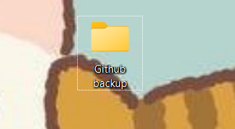

Step 2

In Notepad and type the below script . Make sure that in set REPO_URL give the URL of the repository you want to backup and in set BACK_DIR give the file path of the folder which you created in first step . Then save it as .bat format (eg:backup.bat) in Desktop

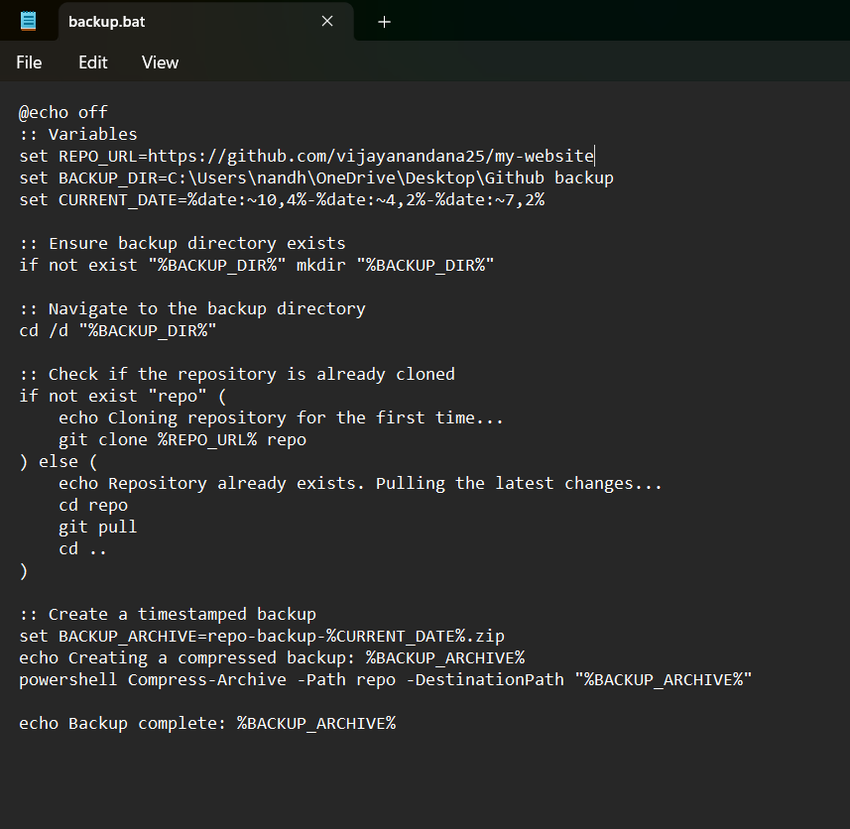

Step 3

* Press Win + R on your keyboard.
* A small "Run" dialog box will pop up.
* Type **taskschd.msc** (without quotes) in the Run box.
* Press Enter or click OK.This will open the Task Scheduler window.

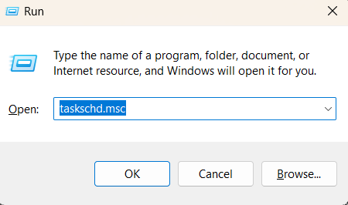

Step 4

In the Task Scheduler window, look to the right-hand side for a button called "Create Basic Task". Click it. A wizard will open to guide you through the setup.

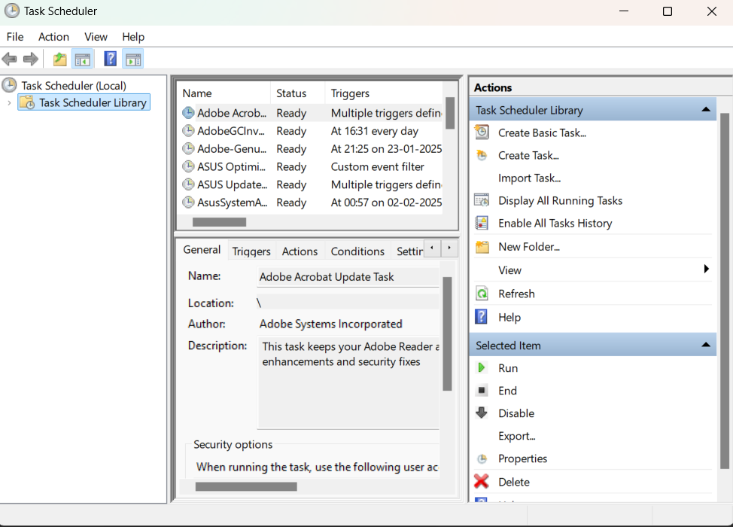

Step 5

1. Enter a Name for the Task: For example: "GitRepoBackup".(This can be anything that helps you remember what the task does.) Optionally, you can add a description like "Backsup files daily".

2. Click Next to continue.

3. Choose a Schedule.

4. Set the Action Now, we tell Task Scheduler what to do when it runs. Select "Start a Program": On the "Action" screen, select the option "Start a Program" and click Next.

5. Click Finish to save and schedule the task.

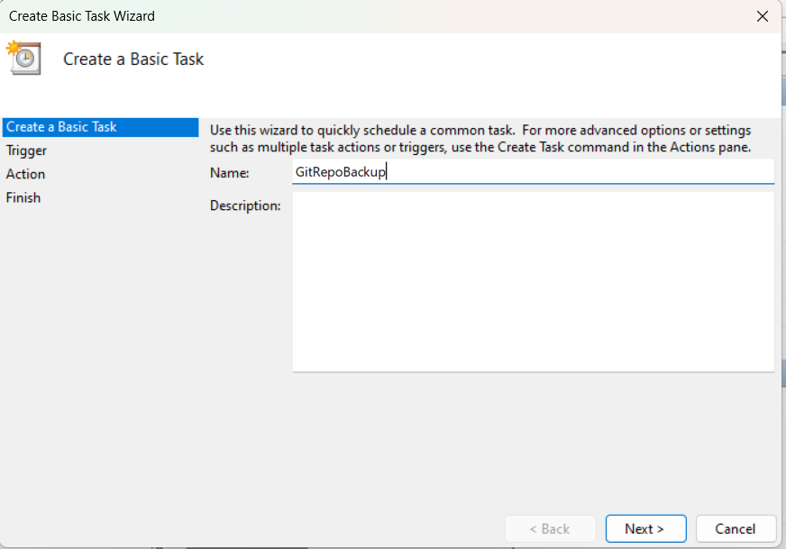

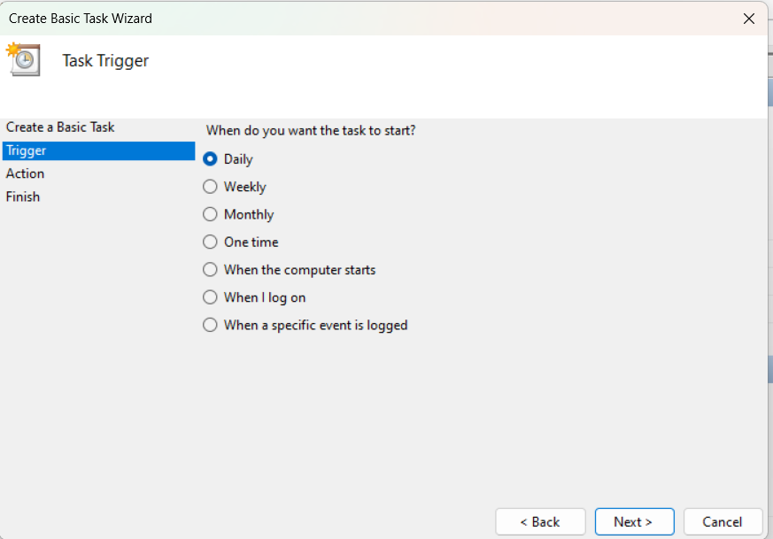

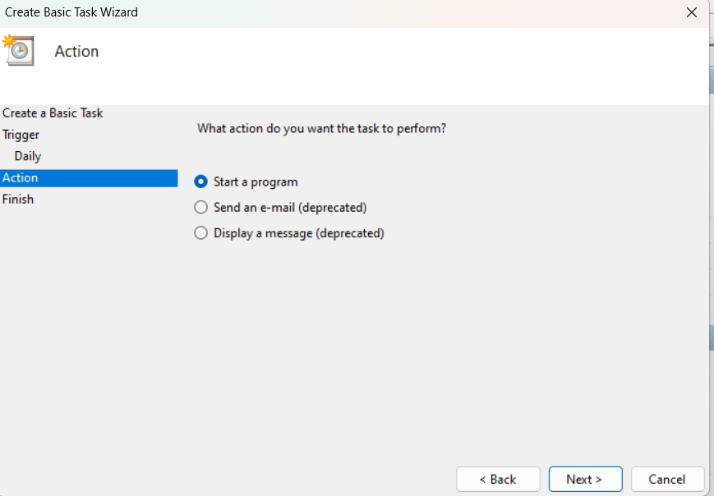

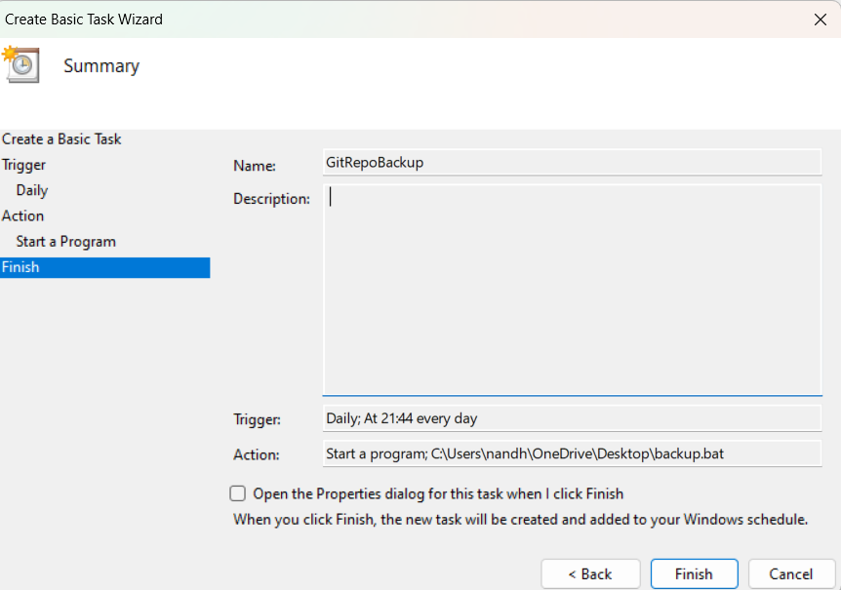

Step 6

In Task Scheduler, go to the Task Scheduler Library. Find your task. Right-click the task and select Run. This will manually trigger the task immediately

Now u can see the folder which you created (GitHub Backup Folder) in the first step will now contains the files which is in your repository.

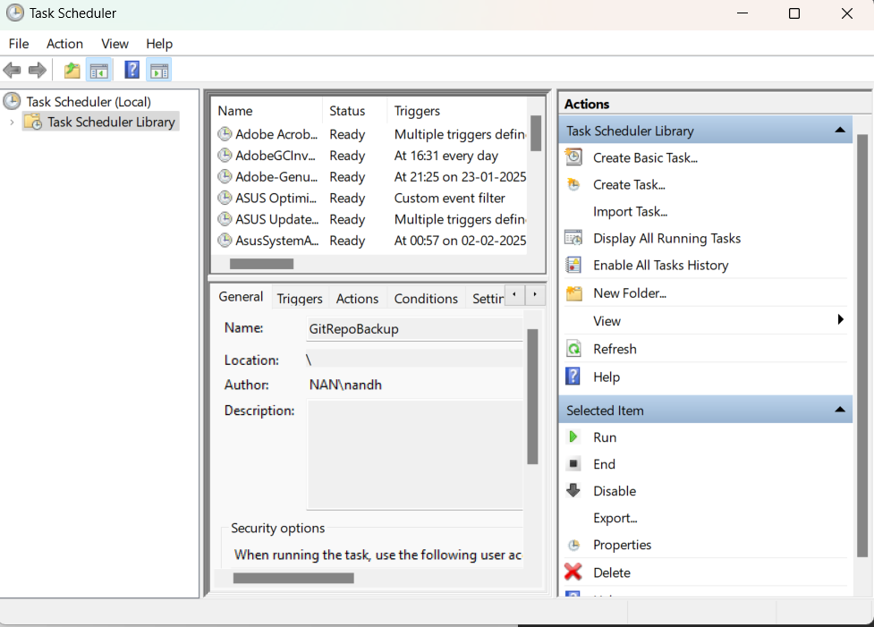

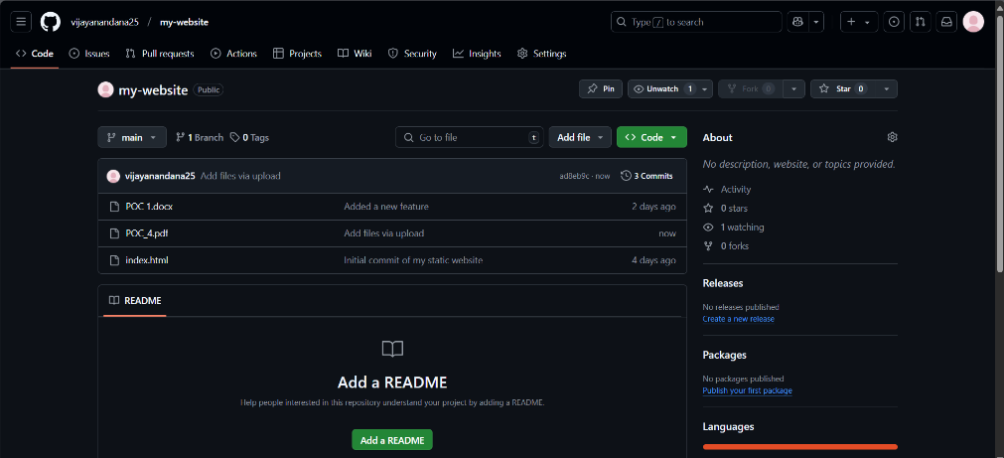

**Expected Outcome**

By completing this PoC of setting up a local Git repository, you will:

**Successfully implement a backup system for Git repositories**: Automate the process of creating daily backups for your Git repositories, ensuring that all updates and changes are securely stored in a local folder.

**Master the use of batch scripting for task automation:** Learn to create and execute a .bat script that clones, pulls updates, and compresses a Git repository into timestamped backup archives.